**The *Schneider Prize for Technology Innovation*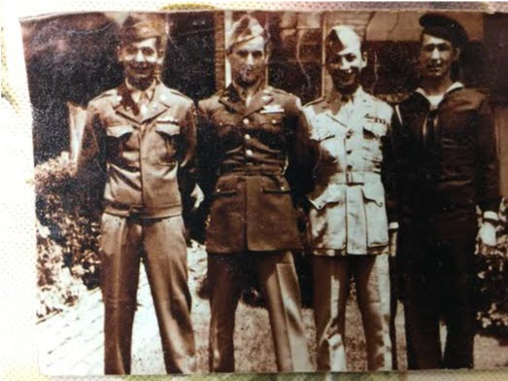**

(L-R) Frank Schneider, US Army; Dr. Tony Schneider, US Army Air Corps; Dr. Henry Schneider, US Marines; Edward A. Schneider, Jr, US Navy

The Schneider Prize for Technology Innovation was founded in 2017 to honor the accomplishments of the Schneider family of York County, PA. Four brothers from York enlisted in the four branches of the military during World War II, while their sisters and parents served at home. The brothers returned to become scientists, engineers and civil servants, making their mark on our community. This prize honors their family’s achievements in our community and will be awarded to a Hack that results in ideas and innovations for communicating and educating about specific technology.

In 2018, the prize was offered to the developer or team of developers that could improve upon the use of our current Grease Thief**®** technology. The winning team shared the $1000 prize for their coding design and solution for creation of a criteria data set that generated actions based on lubricant color changes. This led to our current patented Grease Thief Colorimeter that customers can use on-site to analyze and quantify color changes in grease.

In 2019, the Schneider Prize focused on hacking our existing technology videos used for training and education to improve effectiveness with the use of various image and video processing tools or ideas for format and content enhancement. The winning team used augmented reality to show how our Grease Thief T-handle sampler works, helping customers better understand the sampling processes.

The challenge of the 2021 Schneider Prize for Technology Innovation will be:

***Using a Raspberry Pi develop a program that will connect and collect data from multiple devices (e.g. bar code scanner, scale, ferrous debris measurement, and color measurement) that will be uploaded to a website via a HTTP request.***

This year will be focused on development of the GreaseMonkey robot using a Raspberry Pi device. Teams who show interest in competing for Schneider Prize will create a program to read data from devices and upload to a website via a HTTP request. The teams will be provided with a GitHub repository that contains a locally hosted webpage, CSV file to simulate data, and a technical guide. The GreaseMonkey robot will be present for teams to observe how their program could be applied. Each team’s solution will be judged on design, execution, coding style, and creativity. The team that makes the best program to integrate with the GreaseMonkey robot will receive a $1000 Grand Prize. If a second worthy submittal is received, a Reserve Prize of $500 will also be awarded.

More information and ideas will be presented in a brainstorming session given by JD Brown Center for Entrepreneurship Center member MRG Labs during the Hackathon. Insight will be provided by Rich Wurzbach (President), Zach Redcay (Engineering Intern) and Richard Janosky (Lab Manager). Good Luck to all the Hackathon participants!